College 101

2/5 – GH Symposium (virtual)

Sr. Trip Meeting
(Pmt and intent to attend)

Course Selection Mtg

College 101

8/24 – Picture Day

FEB
AUG

College 101

9/17
Homecoming Game
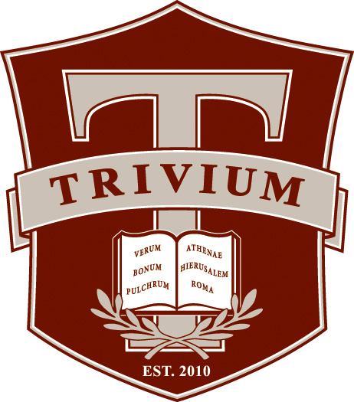

3/25
School Day SAT
3/25
Essay, resume, college list, LOR due, meet with college counselor

MAR
SEP

4/5
School Day ACT
College 101

Fall Break
1-10th

Conferences
11-13th

OCT
APR

College 101

5/15
Colleges changed to active in Naviance

NOV
MAY

JUNIOR
YEAR
EVENT
GUIDE
2019-2020

College 101

College List
12/16

JUNE

College Visits

Sr. Thesis

DEC

JULY
JAN
College 101

College List due in Naviance

Beginning of group fundraising for
Senior Trip
(volunteers needed)

Work on Senior Thesis

College Visits

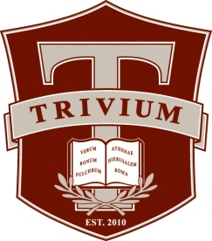
------------------------------------------------------------------------------------------------------------------------------
College 101:
The Office of College Counseling at Trivium Preparatory Academy believes that the process of applying for college should be one of positive self-discovery that fully engages students, parents, and counselors. We help students assess their individual abilities, talents, interests and aspirations, and we provide the knowledge, guidance and support for students to identify and seek admission to appropriate colleges and universities. Our aim is for students to consider carefully a range of “good matches,” creating the best possibilities not only for acceptance, but also for success once enrolled. College 101’s are directed toward Juniors to prepare them for a successful Senior year. The book you purchased, College Match, will be used heavily during the course of the year. These 101 will be held during lyceum with your assigned college counselor.
----------------------------------------------------------------------------------------------------------------------------------------------------------------
College 101 overview

College Match: Worksheets 1-3 will focus on finding the right college fit for you. You know yourself better than anyone. Students will complete the worksheets and evaluate themselves on what they are truly looking for in a college. These will aid in choosing which college will fit you the best and debunk 13 myths about which college you should select.
College Match: Worksheets 4-9 will focus on what type of college is right for you. Size (large, medium, small), location, academic offerings, college sports, intermural sports, rigor, weather and other factors will help you to narrow your focus on what college is right for you. Where will you thrive?
Resume and professional writing: Learning how to format a resume and what should be included, including specific target ways to make your resume shine. There are specific electronic formats which are required for applications. Putting your best foot forward by learning how to email, text or call in a professional manner.
Link PSAT scores with Khan Academy
College Match: Worksheets 12-13 will focus on working on sample essays. This process will give you hints for writing excellent essays and assist you on thinking through your answers for the essay prompts provided by the Common App. We will also go over Letters of Recommendation: how to request one and how to choose who to write you one.
Work on essay, resume, job shadow, and college list.
Carefully review your college list and update it.
Review types of applications; EA/ED/RED/ROLLING/RD and go over the college application time table.
Make sure your college list is complete and updated in Naviance and moved to active applications. Have a interview with your college counselor.

----------------------------------------------------------------------------------------------------------------------------------------------------------------

----------------------------------------------------------------------------------------------------------------------------------------------------------------

Roles and Expectations

The College Counseling department at Great Hearts believes in identifying the role of the student and parent in the College Counseling process. Each person has a specific role and expectation.
Student:
- Take an active and leading role in the process
- Pay attention to announcements, emails, and meeting requirements with your CC
- Check in with parents and keep them aware of deadlines
- Review your transcript
- Create and keep a current college list in Naviance
- Keep CC informed of your progress and any problems you experience
- Meet your deadlines
Parent:
- Continue to guide and support your son or daughter in this process
- Encourage your student to take the lead and accept responsibility for this process
- Be an objective participant in this process
- Be positive
- Inform CC of any questions or concerns you have so we may work collaboratively on behalf of your student

----------------------------------------------------------------------------------------------------------------------------------------------------------------
COLLEGE CHECKLIST
- FOCUS ON STUDYING
- PSAT PREPERATION
- SUMMER PROGRAMS
- GATHER ACHIEVEMENTS AND AWARDS (WWW.COALITIONFORCOLLEGEACCESS.ORG)
- VOLUNTEER
- VISIT COLLEGEBOARD.ORG
- START MAKING PLANS TO VISIT COLLEGES
- CREATE A PROFILE ON NAVIANCE STUDENT
----------------------------------------------------------------------------------------------------------------------------------------------------------------

